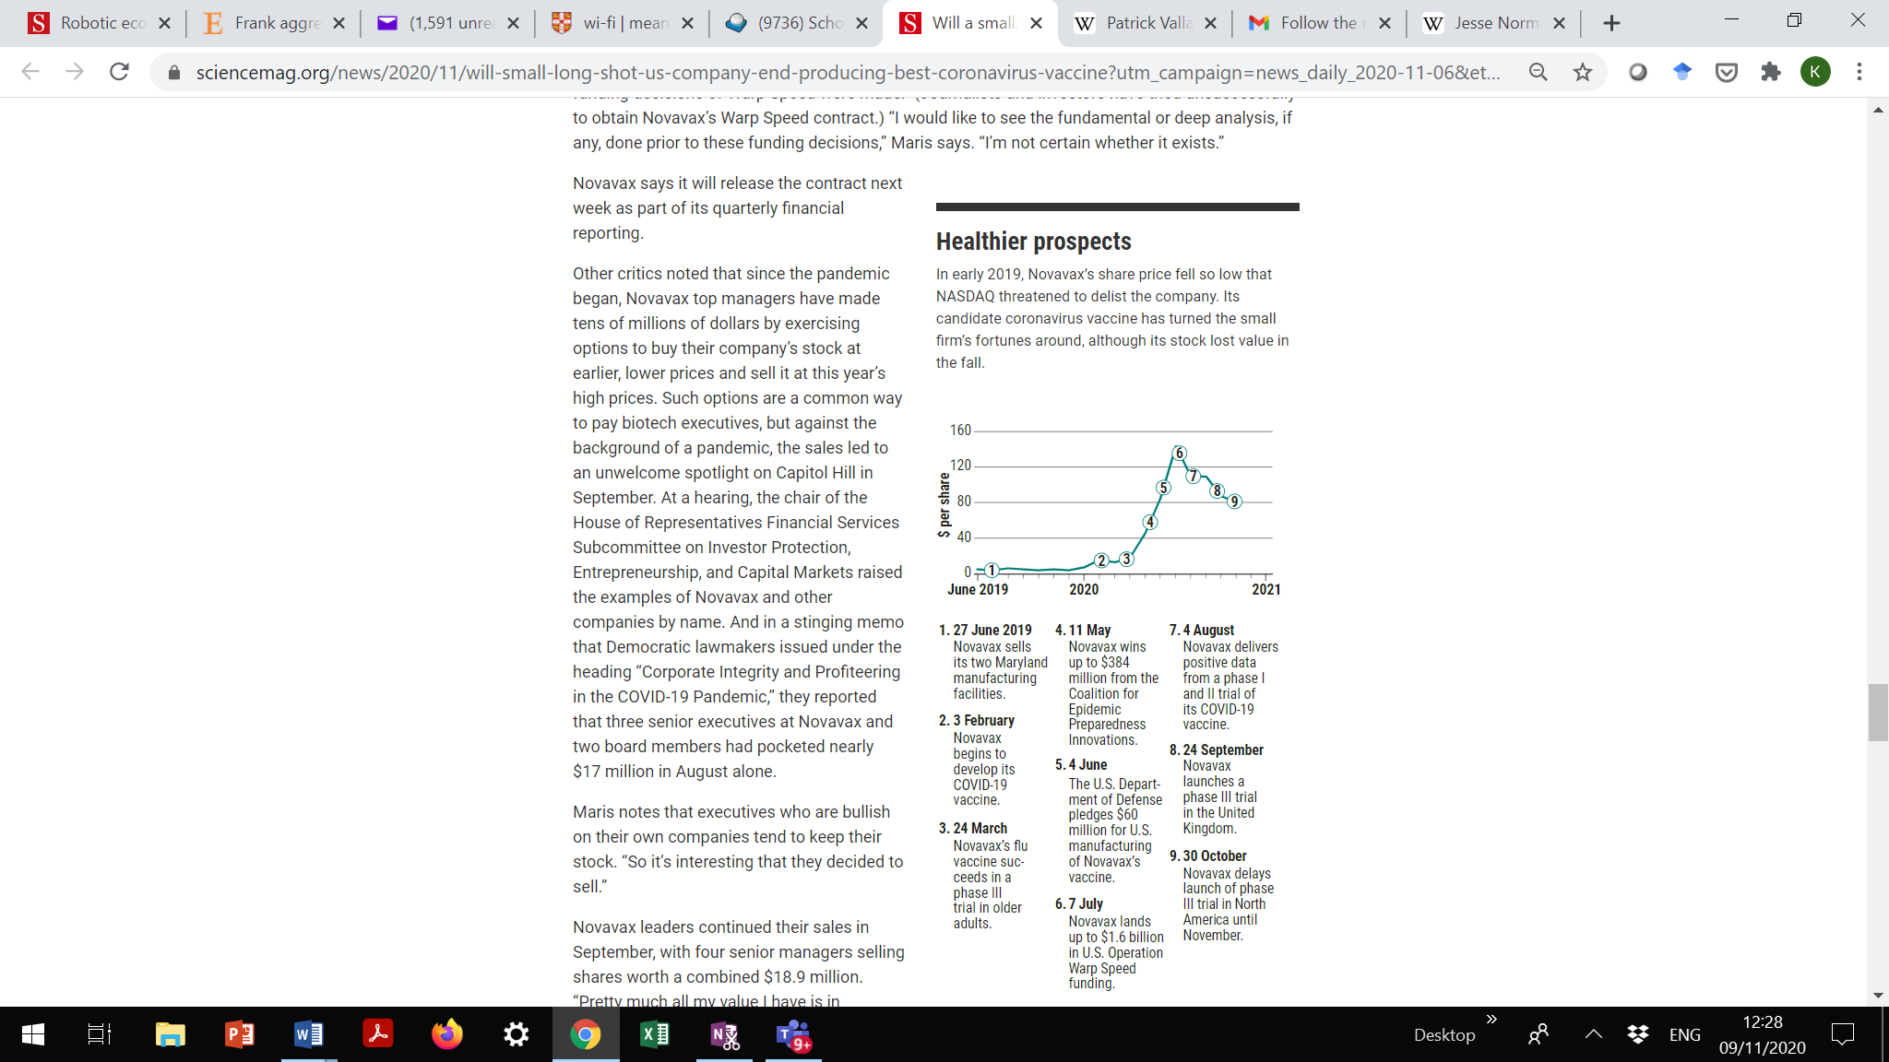

<https://www.sciencemag.org/news/2020/11/will-small-long-shot-us-company-end-producing-best-coronavirus-vaccine?utm_campaign=news_daily_2020-11-06&et_rid=79654960&et_cid=3547595>